Responsive Product Card Testing

Desktop View:
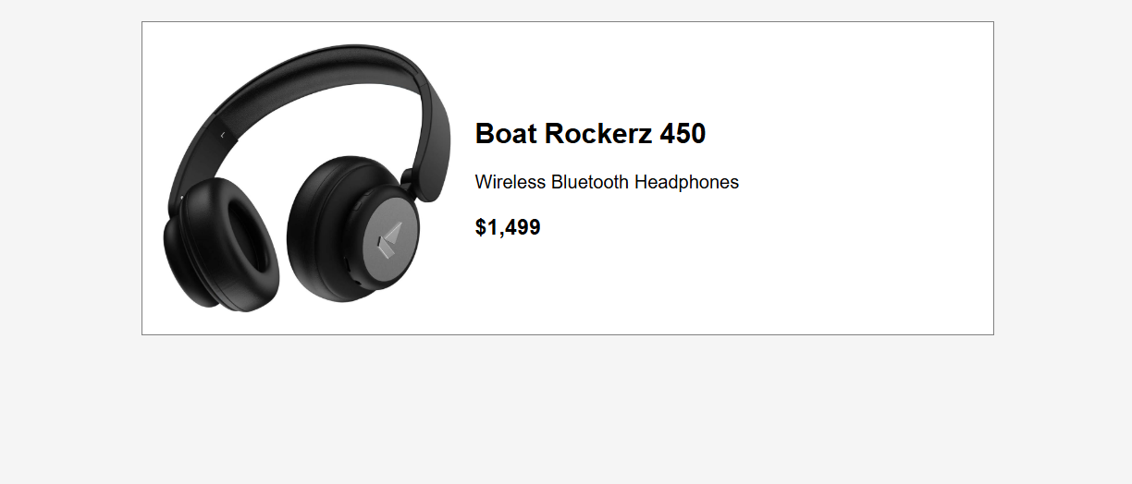

The product card is displayed in a horizontal layout. The product image appears on the left side and the product details are displayed on the right side.

Mobile View:
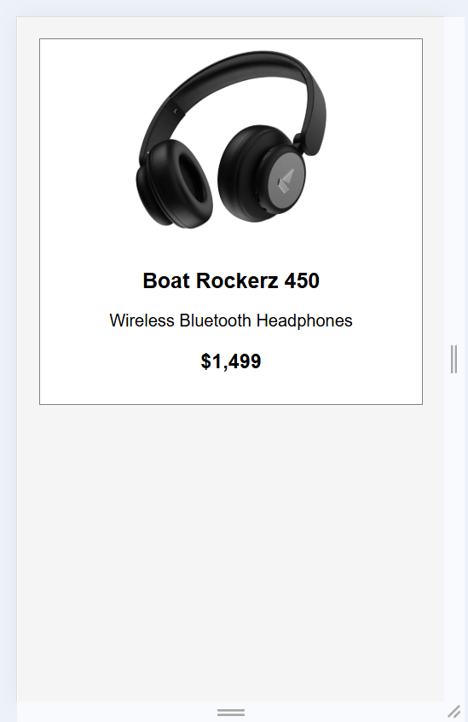
Tablet View:
